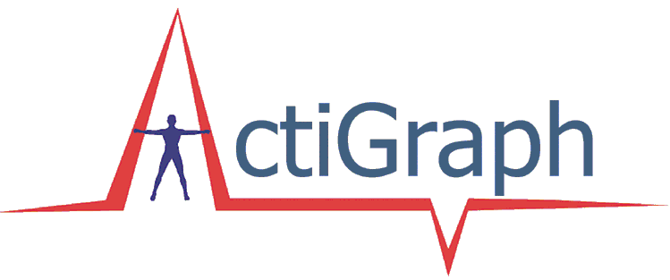

Borrower’s request for accelerometers
from CLOCC

Borrower’s Contact information
Borrower’s Name:
Please provide credentials
Organization’s Name:

Address for accelerometer delivery (Note: P.O. Boxes not acceptable):
City, State: | Zip:
Work Phone: | Cell Phone:
Email Address:

Accelerometer Request:
Request  1 | Pick-up date:  ____________ | Date and time to start  Collecting data:___________ | Return date:  __________ | # of accelerometers  requested:________ | Epoch (collect data  every x seconds):_____
Request  2 | Pick-up date:  ____________ | Date and time to start  collecting data:___________ | Return date:  __________ | # of accelerometers  requested:________ | Epoch (collect data  every x seconds):_____
Request  3 | Pick-up date:  ____________ | Date and time to start  collecting data:___________ | Return date:  __________ | # of accelerometers  requested:________ | Epoch (collect data  every x seconds):_____

Please provide a brief description of your project:
Type here

How will the data be collected/processed?

1. We, (the borrower) will complete the accelerometer initialization and downloading of the data.

2. We, (the borrower) have made/will make arrangements with CLOCC to perform all work related to the
accelerometers and have received IRB approval for CLOCC to assist us in this procedure.

Please Note:

a) You will be required to sign a User Agreement with CLOCC for liability. CLOCC takes no responsibility for damages to the devices. If damaged or lost, you will be responsible for the cost of replacing or repairing the equipment including the cost of returning the devices to Actigraph by courier.

b) You will be required to pick up and return the accelerometers from CLOCC’s office at 680 N. Lake Shore, 13th floor.

c) You will be required to remove accelerometer units from the elastic belts and wash the belts before returning borrowed materials (belts, accelerometers, chargers, cords) to CLOCC.

